Section 7.2: Design guidelines
This worksheet provides guidelines of different design types, and ways of organising information. Under each heading you will find a description of each type, along with any relevant guidance on key features.
1. Outline system design: System flow chart
System flow charts are a way of displaying how data flows in a system, and how decisions are made to control events. The symbols used are:
 | Process  This could be:  - a program  - a manual process.
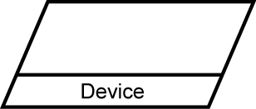 | Input/Output  This could be:  - data keyed in at a keyboard  - barcode read with a barcode reader  - error report output on a printer  - graph shown on a monitor.
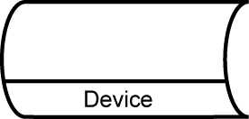 | On-line storage  This could be:  - a database on magnetic disk  - a data file on CD-RW.
Flow line
Links the symbols to define sequence and direction of flow.

These symbols are used to show how data flows and how decisions are made. They are connected together to show what happens to data and where it goes. System flow charts are very similar to data flow charts but data flow charts do not include decisions, they just show the path that data takes.
2. Hierarchy chart
A hierarchy chart illustrates the relationships between the modules in the system. It does not tell you what tasks are to be performed within a module. It does not tell you when or how a module executes; it identifies which modules exist and which modules call which other modules. They help the programmer in dividing a software problem into parts that are small enough to be understood. Programmers do not write programs as one long series of steps, they break the programming problem down into reasonable units, called modules and tackle one task at a time. If a subroutine or function is useful and well written, you may want to use it more than once within a program. A good policy is to place statements that perform one specific task together.
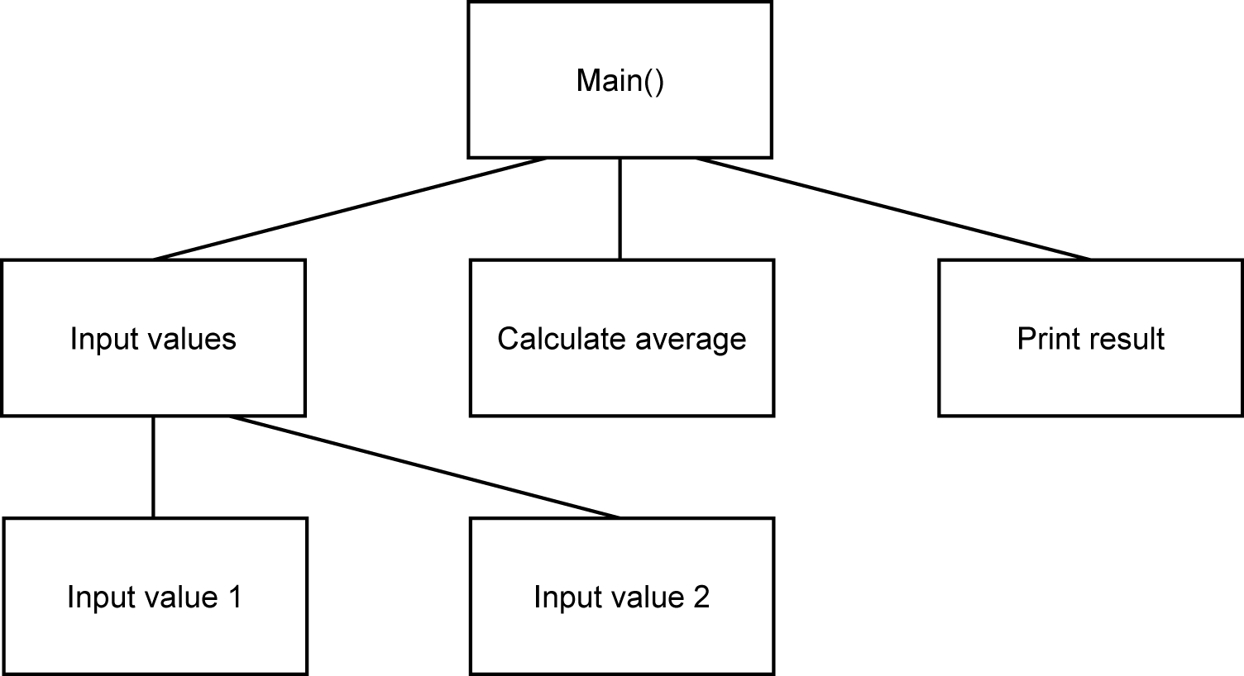
The hierarchy chart for a number-averaging program shows which modules call which others.
3. Structure chart
A structure chart is a hierarchy chart with interfaces and control information. It does not tell you what tasks are to be performed within a module. During the actual building of the program the chart is continually referred to. Often, it is modified as programmers learn new details about the program. After a program is completed, the structure chart is used to fix bugs and make changes (maintenance). It is especially important in this stage, because often the original programmer may be gone, and a programmer new to the project uses the chart as a navigational tool into the source code files.
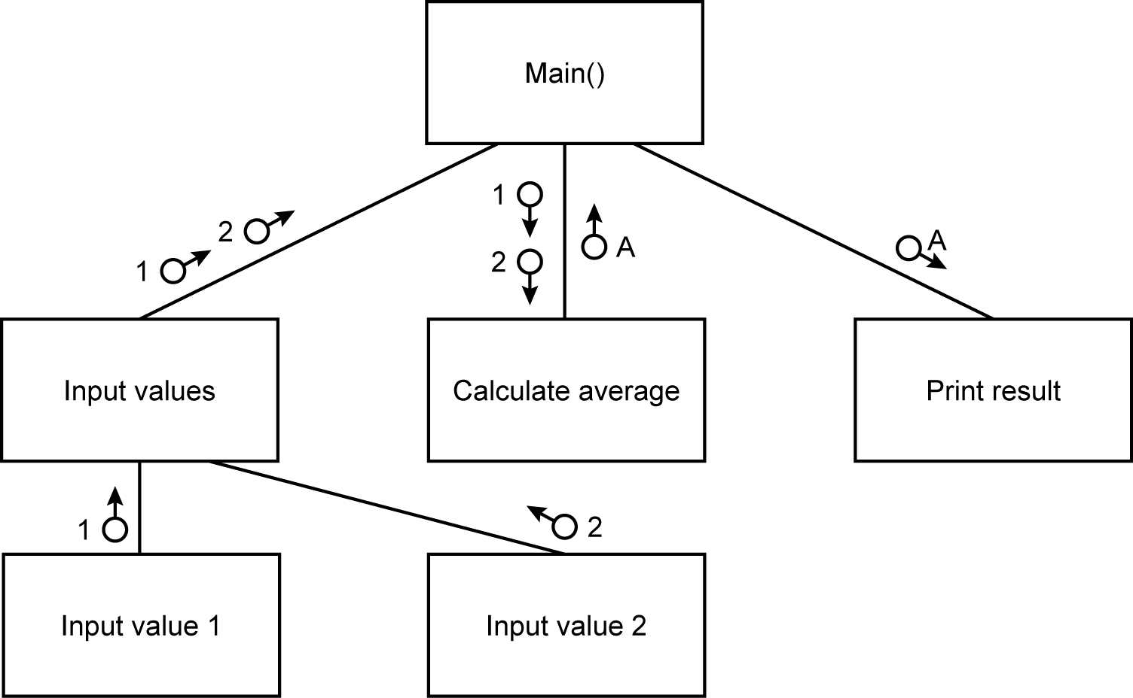
The structure chart for a number-averaging program shows how the data is imported and exported from each module.
4. Algorithms using structured English or pseudo code
Pseudo code is an informal, high-level description of an algorithm. It is intended to be easy for people to read rather than for computers to read. Pseudo code typically leaves out details that are not essential for people to understand what the program does, such as variable declarations. Pseudo code can include descriptions of the details, where convenient, or with mathematical notation. It should be a compact and environment-independent description of the key principles of an algorithm. No standard for pseudo code syntax exists, as it is not an executable program.
You should include:
- a description of any validation that will take place.
- algorithms for reading data from files/database and writing data to files/database
- processes for data transformation, i.e. how the data input is converted to the correct format for
  - saving/processing, and how the data output is created
  - processing algorithms – those that carry out the functions of the system.
- Object diagrams and class definitions
Object and class diagrams are required where you are using an object-oriented development environment. Class diagrams show the classes of the system, their interrelationships (including inheritance, aggregation, and association), and the methods and attributes of the classes.
Classes are depicted as boxes with three sections, the top one indicates the name of the class, the middle one lists the attributes and fields of the class which it has inherited, and the third one lists the attributes and methods that are additional to the class.
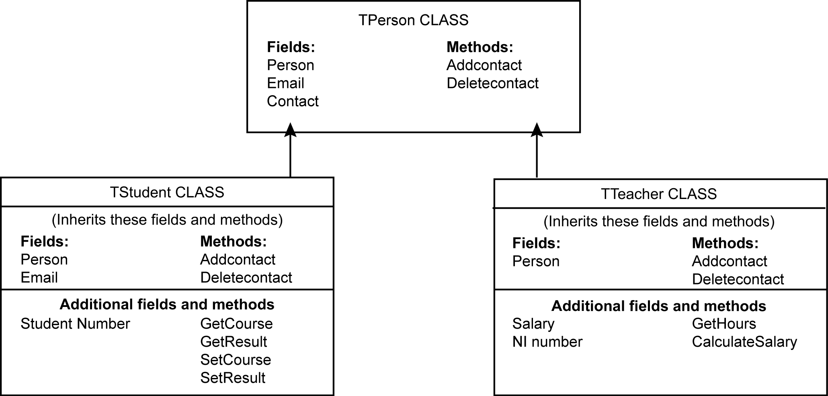
6. Prototyping
A prototype is a simplified working model of a system. It is an ideal means of communicating with the end user to check that the design meets the user’s needs. Show the prototype to the user and discuss issues of design. For example, the user may suggest that terminology used in the interface is not what the user is accustomed to, or that not enough/too much space is allocated to a data entry. Maybe a menu option is missing.
7. Hardware specification
The specification of an appropriate hardware configuration must be sufficiently detailed to be able to purchase the required components. Each component required should be identified and specified:
- input devices keyboard, mouse, touch screen, scanner, digital camera
- output devices, monitor, graphics card, printer,
- storage devices, hard disk drive, temporary storage devices, backup devices
- processor and main memory requirements
8. Design data dictionary and data structures
Use the analysis data dictionary and add entries for variables you need for processing purposes. Decide on data types for all data items; this could include data structures such as arrays or records. Add validation rules with reasons why they are required and what they are testing. How are the values to be stored while the program is running and what data need to be stored long-term? Are data to be stored in database tables or files?
9. File organisation
Files stored on magnetic disk can be organised in a number of ways. There are advantages and disadvantages to each type of file organisation, and the method chosen will depend on several factors such as:
- how the file is to be used
- how many records are processed each time the file is updated
- whether individual records need to be quickly accessible.
The available methods include:
- serial
- sequential
- indexed sequential
- random.
Choose between simple text files, CSV files or typed files.
If data is stored in arrays while the program is running, but needs to be stored long-term, then serial or sequential file organisation should be considered.
If the program is to access data records held on disk as and when required, then a random access file organisation might be more appropriate.
10. E-R model and diagrams, and normalised database tables
During the analysis phase you drew a diagram of the entities in your system. The relationships between the entities were identified – one-to-one, one-to-many, many-to-many. In order to implement the system, many-to-many relationships need to be resolved into one-to-many relationships using link entities. Use the entity descriptions identified to organise the attributes into tables so they are fully normalised.
11. Human–Computer-interface design
User interface design should include input/output, forms and reports. The user will be faced with an initial interface screen, possibly with menus, help and input screens. You should give an idea of what these are going to look like. This should comply with anything you have said in your analysis about screen design. You should give good reasons why you have designed the screens in the way you have, if necessary designing several alternatives and selecting which one is best, by referring to the users.
Your aim is to produce good HCI design that prevents errors occurring and minimises the amount a user has to remember.
Points you should consider when designing your screens:
- Users needs and useability.
- Input/output devices.
- Colour; do not use it unnecessarily; use dark colours on a light background or vice versa.
- Have headings so the user knows where he/she is in the system.
- Include instructions on the screen where necessary, including reference to help and manuals.
- Indicate where the user is to enter data.
- Indicate the format of the data.
- List error messages, feedback and dialogue boxes, and make sure they are user friendly.
- Avoid clutter on screens and reports.
- On-line help.
- Shortcuts.
- Consider icon usage and presentation.
- Exits should be clearly marked.
- Consistency in your design.
Sketch the input screens and the outputs from the system.

